Question 1:An RGB color image has a spatial resolution of 640 × 480 pixels.
Each pixel is represented using 8 bits per color channel (R, G, and B).
1. Convert the given RGB pixel (R = 120, G = 200, B = 80) into its equivalent grayscale value using the standard luminance equation. (3 marks)
2. Convert the same RGB pixel (R = 120, G = 200, B = 80) into the HSV color model.
Clearly show the calculation of Hue, Saturation, and Value. (4 marks)
3. Calculate the total size of the RGB image in megabytes (MB) before compression. (2 marks)
4. After applying an image compression technique, the image size is reduced to 450 KB.
Calculate the compression ratio. (2 marks)
5. If the image is transmitted at 25 frames per second,
determine the required bit rate for transmission of the compressed image. (1 mark)
Question 2:A grayscale digital image has a spatial resolution of 1024 × 768 pixels and is represented using 6 bits per pixel.
1. Calculate the total number of pixels in the image. (2 marks)
2. Determine the gray level resolution of the image and specify the intensity range. (2 marks)
3. Calculate the total memory required to store the image in kilobytes (KB) and megabytes (MB). (3 marks)
4. The image is obtained by sampling a continuous-time image signal having a maximum frequency of 4 kHz.
• Check whether a sampling frequency of 7 kHz will cause aliasing. Justify your answer using the sampling theorem. (3 marks)
5. Explain 4-connected, 8-connected, and m-connected pixel connectivity with neat diagrams. (2 marks)
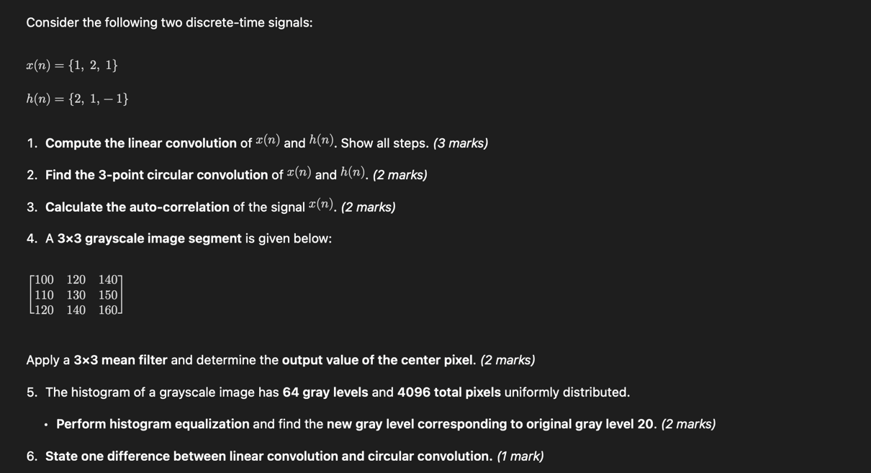
Question 3:

Question 4:Design a digital low-pass FIR filter using the window method to meet the following specifications:
- Passband edge frequency, f_p = 1 kHz
- Stopband edge frequency, f_s = 1.5 kHz
- Sampling frequency, f_{sampling} = 8 kHz
- Minimum stopband attenuation = 40 dB
- Determine the normalized digital passband and stopband frequencies. (2 marks)
- Select a suitable window function to satisfy the given attenuation requirement and justify your choice. (2 marks)
- Calculate the transition width and estimate the order of the FIR filter. (3 marks)
- Write the expression for the ideal impulse response of the low-pass filter. (2 marks)
- Explain how the selected window modifies the ideal impulse response to obtain the practical FIR filter. (2 marks)
- State one advantage of FIR filters over IIR filters. (1 mark)
Question 5:
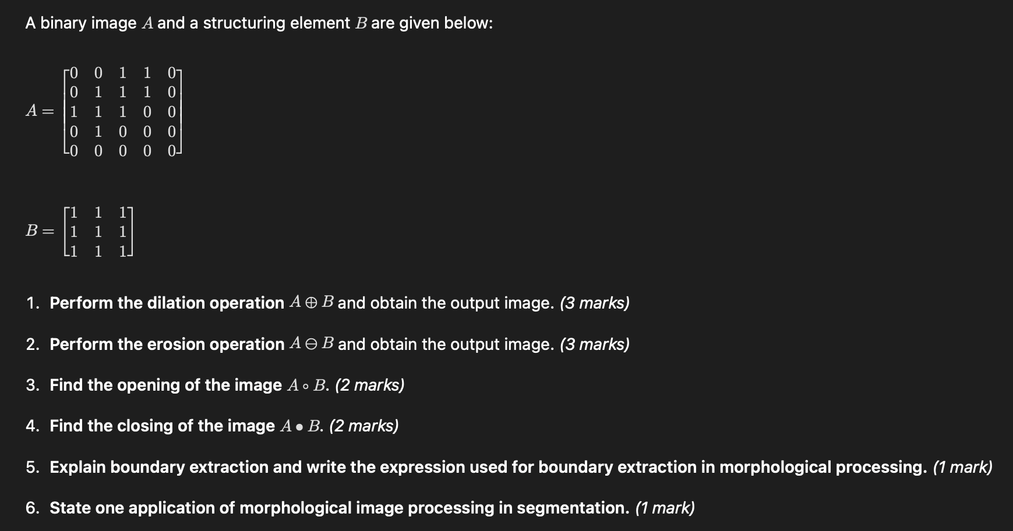
Question 6:
Consider the discrete-time signal
x(n) = {1,0,2,0\}, n = 0,1,2,3
- Compute the 4-point Discrete Fourier Transform (DFT) of the signal x(n).
Show all steps. (4 marks)
- Find the 4-point Inverse Discrete Fourier Transform (IDFT) of the result obtained in part (1) and verify that the original signal is recovered. (2 marks)
- Perform the 4-point Fast Fourier Transform (FFT) of x(n) using the Decimation-in-Time (DIT) algorithm.
Draw the butterfly diagram and compute the final FFT output. (3 marks)
- Verify the linearity property of the DFT using the signals
x_1(n) = {1,0,1,0} and
x_2(n) = {0,1,0,1}. (2 marks)
- State one advantage of FFT over direct DFT computation. (1 mark)

